| **WEEKLY INTERNSHIP REPORT BY STUDENT** |
| --- |

| Student Name: Chiu Cheng Wai, Winston  Diploma: Game Development & Technology  Module: Internship Project  Company Name: NTU ARISE | Admin No: 212668S  Period: **4** |
| --- | --- |

Note: The third(3rd) question of each week’s report has been removed, referring to the internship log [here](https://docs.google.com/document/u/1/d/1XDheAPcZ2M_03nruiw8ATAp4bW0EqGOUAUZJkGK0zzY/edit)(Click the link to access the other document)... for the tasks done during that week, as well as any other tasks that encompasses more than a week.

# **Week 1 - <20/11/2023> to <24/11/2023>**

1. What are your initial reactions to your first few days? What are you looking forward to? Is there anything you are disappointed about?

The first few days were filled with briefings, training as well as field work where we had to interact with elderly to facilitate game sessions, competitions and administer surveys. This requires a large amount of social skills, patience as well as certification for MOCA and SPPB tests. This allowed us to interact as well as identify our main consumer for further user stories as well as our target audience for the project. As such it was quite a fulfilling experience to help seniors and first hand interaction with them.

I was slightly disappointed that there weren't active development projects at the moment, but came to understand that they were in the peak of field work and preparation for I-SING(International - Singapore Intergenerational Games). As such, we needed to carry out more field work to help with such a large event. Although, we were notified that the event would be ending soon and any development and programming work would be carried out shortly after.

1. Read the entire website of the organization and read relevant marketing materials about the organization(If possible, ask for an annual report or similar document). Do a summary of what the organization is about and does.

Website of Organization: <https://www.ntu.edu.sg/arise>

ARISE(Aging Research Institute for Society and Education) is a pan-university institute, founded in 2016, at NTU focused on **aging-related research, programmes and activities** to address the demands of an aging population. ARISE acts as a **coordinating body to synergise the efforts and resources** between various groups, both within NTU and trans-organization, to **optimize the outcomes and impacts** of our efforts to benefit the individuals in particular, **communities and society** in general.

Their Vision: “Empower the aging community. Improve the quality of life.”, corresponds to the institute’s four research thrusts: Aging Medicine, Social Integration and Education, Aging-in-Place, Care and Lifestyle Enhancement.

Their Mission: to Empower healthy, active and independent individuals and improve their quality of life through deep understanding or psychological issues, meaningful social integration and productivity enabled by technologies.

Outreach: they have 3 major annual events: Industry and Community Engagement(ICE), Research Symposium and Thrust Networking Series.

Currently, they are hosting I-Sing 2023 as an reopening after the Covid-19 pandemic.

# **Week 2 - <27/11/2023> to <01/12/2023>**

1. Provide some details about the history of the organization.

NTU launched the Ageing Research Institute for Society and Education (Arise) on May 6 2016 with S$12 Million in funding, alongside another S$7 Million for Centre for Population Health Sciences (CePHaS).

As of writing, 8 Aging Medicine projects, 8 Social Integration & Education projects, 4 Aging-In-Place projects and 3 Care & Lifestyle Enhancement projects have been planned for and executed(23 total). Not only that, Arise has 8 co-funded projects and 7 grants between other schools, primarily School of Communication and Information and School of Medicine(15 total). Lastly, they have 6 industry projects with Grab, ETH Zurich, SkillsFuture Singapore and Lions Befrienders Service Association(Singapore).

This brings their total activity to 54 active and closed Projects. For a industry and school level organization, 54 projects within 7 years means an average of 7.7 projects per year, no small feat achieved.

They are also the leading party in the Singapore Intergenerational Games(Sing), created in 2016 domestically, before spreading internationally in 2018 to become International Singapore Intergenerational Games(I-Sing). Other countries include Japan(FWBC), Finland(TUAS), France(E-Seniors Association) and Taiwan(National Taiwan Sport University). Started with using the Kinect, now using the Nintendo Switch, they aim to develop their own games as well use mobile phones, ARVR technology and more to provide a more fun and fulfilling experience for the elderly.

In 2017, they carried out a Industry & Community Engagement Event and Research Symposium(ICE) focused on “War Against Diabetes”. Similarly, a similar Seminar in 2018 focused on ”Aging, Frailty & Loneliness”.

Lastly, they signed an Memorandum of Understanding(MOU) with Lions Befrienders(LB) in April of 2022, mainly for LB’s experience in elderly health coaching training, research and course development. This agreement is slated to last 2.5 years, where over 600 staff and volunteers will be trained in elderly health coaching and the co-development of specially tailored short courses for the elderly.

1. Get a copy of the organizational chart and job descriptions within the organization or department. Show it below.

Working directly alongside Thomas Koh, Tran Nguyen and Chris BX for internship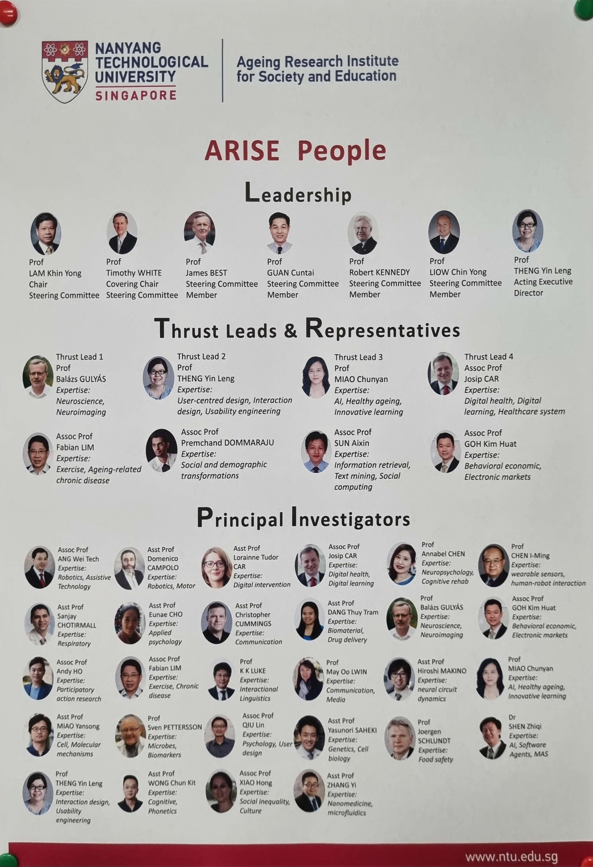

Primary Jobs include Leadership Roles, Thrust Leads and Representatives as well as Principal Investigators.

# **Week 3 - <04/12/2023> to <08/12/2023>**

1. Ask your supervisor their career story. Summarize their story below.

Chris BX: was in TP taking engineering(course name changed), chose psychology as general study module. Further career path choice after National Service in ACORN, helping facilitate and participate in student focused programmes. Pursued psychology as a postgraduate degree in NTU.

Thomas Koh: aerospace engineering 2011-2013 at NP, worked in aerospace before coming to ARISE in 2022.

1. If you have identified challenges or disappointments in your initial expectations of your internship(from week 1), put together an action plan to deal with these. List the plan below.

Despite my initial disappointments in internship, the competition I-Sing is now over and thus I am allocated roles and tasks that reflect a developer, such as building and deploying apps. I have also realized that my initial preconceptions of having a job in a research institute would be rather novel, but it seems that it is like every other job, where you are allocated tasks that benefit the community and the company, with the team and the overall job being rather important to the research.

There is no need for an action plan to be carried out as these stems from my inexperience of jobs outside the developing field, with the only goal being to be able to experience life from more perspectives and thus be able to think like/think of other positions when considering user stories and the overall target audience.

# **Week 4 - <11/12/2023> to <15/12/2023>**

1. What is your biggest challenge in this internship?

I feel like the biggest challenge in this internship is the long travel times between each center, which otherwise would be shortened with good planning and logistic skills. Other than that, I feel like my weak interpersonal skills and introverted nature was put to the test upon interacting with many seniors. However, I would rather interact with seniors than other demographics as they have more energy and are more willing to participate and answer/ask questions.

1. Do you feel like you fit into the organization so far? Why or why not?

Yes, I feel like I fit in this research organization as the tasks given to me were within my capabilities yet pushed me to learn and adapt while working. I also interact with others more often, allowing me to be more vocal and transmit my thoughts and intentions more clearly, which is an important learning factor. The overall goal of the organization is for the elderly to lead more fulfilling lives as well as reduce the impact of solitary aging, thus it resonates with my sense of filial piety as I believe that we should empower/bring joy the previous generation as they paved the road for us to do so. Thus, I feel a sense of accomplishment after the competition on week 3.

# **Week 5 - <18/12/2023> to <22/12/2023>**

1. How has your perception of the internship/organization changed since you started the internship?

Since the start of the internship was a competition, I thought that the centers we visited were the main focus of the internship as we frequented the place often. However, after the event, we resumed work in the office where I was told about the tasks that were in progress, as such it reaffirmed my beliefs that the company was like every other organization where the overall goal and roles of its workers were for the overall well-being and improvement of the target audience, in this case, the seniors.

1. What goals have you met so far? What goals do you still need to meet? Have you changed any of your goals?

I haven't set many goals within this time frame but I have noted a stronger sense of responsibility and eagerness to fulfill my given roles. I also interact more with others and feel that my language skills in both English and Mandarin have improved after practice. I also note that putting my learnt skills to use felt more rewarding compared to assignments in school, which forced students to follow rubrics that ultimately grades obedience and not exploration and expression. Putting skills to use in my own fashion allows me to be more creative and put in more effort as compared to forced conditions.

# **Week 6 - <25/12/2023> to <29/12/2023>**

1. What have you contributed to the organization? In what ways do you feel like you can improve your performance?

I have been assigned interviewing and ushering jobs as well as tech support and logistics by the supervisors. I am primarily tasked to visit locations to interview seniors based on Moca standards, which I have been certified on. I also visit locations to guide and facilitate seniors for the various games they play during game sessions. Lastly, due to frequent equipment changes, I am tasked to track and apply logistic skills to ensure that I have all equipment on hand needed for the day’s tasks, similarly for the period of preparation before the competition event. During freeplay sessions, centers also contact me for tech support roles in order to guide them through the set up and use case of the games sets provided.

Above that, I have been tasked with research and report writing on the functionality and use cases of previous batch work. Due to lack of time, I have brute forced the various macbooks at the office to gather the most up to date files and projects, for the previous batch do not have access to them and not yet updated the repository. I also had to gather ipads and tablets to test the effects, which I have written a report on: [Link](https://docs.google.com/document/u/0/d/1nsL0-tKHZYSiyxxxipEBJx_5mY_sB0y0aLKDQEdoZNY/edit).

1. Is your personality a fit for this organization? Do you notice particular personality types working in this industry?

I have noted no particular personality types in this industry. I am currently working in a research center for the use of technology for the betterment of seniors’ lives, from which, many personality traits come together to allow for the research to be carried out. From the perspective of an intern, I do not interact much with the professors as such I am in no position to identify their personality traits.

Working directly with elderly , however, patience can prove to be a useful tool as well as command of space and attention. It also helps to be fluent in body language and show a high level of attentiveness as a form of respect to the elderly. These traits have greatly helped my experience working with seniors and it is quite rare to have all the traits, such as a few missing traits seen from my intern batchmates. Despite this, they also have a few traits that I hope to emulate, such as playfulness and lighthearted speech, which can put the seniors at ease and more willing to participate in the activities. Such traits can also be seen from the supervisor, which can combine professionalism with lighthearted behavior to guide the seniors as well as interact with them.

# **Week 7 - <01/01/2024> to <05/01/2024>**

1. What surprised you about this internship?

I am surprised how much technology and communication can aid the elderly. From other research projects around the office, I can see that some that focus on the physical aspect, the mental aspect and the technological aspect of a person’s life. Little things such as teaching the elderly new skills, communicating more with them and allowing them to lead more independent lives by use of technology and internet communications.

I-Sing was also surprising as many centers come forward to participate, especially after Covid-19 where the weakened immunity of the elderly poses a huge risk to their health, not to mention the seniors inability to play such games. However, through ARISE’s efforts as well as guidance of the center staff, many grew to love such games and wish to participate in future events.

1. Identify the most boring or routine activity in this experience and put together a plan for turning it into an opportunity for learning something new. List your plan below.

-NIL- everyday has been interesting and challenges me to put in all my effort as well as learn more about my job. I have also looked into past projects and done adequate research in order to learn about them and how they work.

# **Week 8 - <08/01/2024> to <12/01/2024>**

1. Did you work with a diverse range of people?

I work with 3 supervisors, and 2 other interns from other polytechnics. Of which, they major in sociology, psychology and engineering. Other members of ARISE are seldom at the office and I do not have the opportunity of meeting them, but from the organizational chart, they seem to major in communications and medicine. Other than their industry of specialization, they seem to be all asian with the exception of the professors, which I have never interacted with before. Thus, although I work with a diverse range of industries, our cultures are not that different and I do not believe that cultural or racial mishaps will occur.

1. How did people from diverse backgrounds work with each other? What did they teach you?

-NIL- Although I don't work with too many people, I do interact with many people of different backgrounds, mainly the elderly and the center staff. They are all very approachable and friendly, although that may come from age and seniority, and they all have stories to tell, which can be a sign of acceptance and friendliness towards others, no matter their background.

# **Week 9 - <15/01/2024> to <19/01/2024>**

1. What did you learn about yourself through this experience?

I have realized that I work better in smaller teams as well as quieter environments, which may not be fulfilled if i'm working in an office. I also enjoy interacting with others, especially the end product users and seeing how they are impacted by my actions or products. Granted, I haven't completed the webapp yet, thus unable to see the effectiveness of the design and use of it in the office. The webapp is meant to reduce the time taken to record scores as well as improve coordination and organization between sessions, as such I hope that it would be useful.

I have also realized that I am sorely lacking in general knowledge about other forms of programming and I am unable to prototype as quickly as artists/designers. However, I know that with experience and more time learning, I will be able to get rid of this issue.

1. What was your biggest success in this internship? Were your expectations for this experience realistic? Why or why not?

The biggest success would be to stick to a schedule more consistently. I have kept many schedules and commitments over the years and they are formed from personal wants and hobbies, which make it hard to continue after many years. However, I feel that being on a job in my industry instead of part-time can help with my schedules and commitments. My expectations are realistic as I expected this shortly after I reduced my time needed for working out or doing sports, which can be seen as a higher commitment to studies and projects over my personal health. It may seem slightly unhealthy but I have gathered joy from both exercising as well as working. Thus, I feel that my expectations were really realistic, to the point of agreeing with my previous arrangements.

# **Week 10 - <22/01/2024> to <26/01/2024>**

1. What have you done that you didn't ever think you would be able to do?

I didn't think I would be able to interact with others as easily as I had. I am more comfortable talking with the elderly more than people of the same age, but it was easier due to my need to be professional and interact with them for the purpose of data collection and interviewing them.

1. How are you different than you were when you started this experience? What changes would you make if you had the chance to do this over again?

I believe that I mostly stayed the same, with a few exceptions. I spend more time working on projects and office related work while also having a better schedule to work on my own projects and research. I have learnt better research methods and planning/prototyping practices to reduce the amount of time spent preparing. This leads to a more efficient work cycle that I am more comfortable with, instead of over preparing for a few tasks like in the past.

I am able to spend more time working productively but not obsess with my tasks as I am working in a team. I can delegate more tasks once my responsibilities are completed. As such, my quality of work has increased without much stress and the rest can be handled by others.

# **Week 11 - <29/01/2024> to <02/02/2024>**

1. What was your biggest success or contribution to your organization? What did you learn from your challenges in this experience?

Worked on a scoreboard web application to improve the efficiency and ease of collecting scores for competitions. Used unfamiliar language and syntax that allowed me to learn and experiment while developing. However, batchmates do not understand the language either, thus I needed to guide them and teach them while I was learning. While teaching others, I can improve my own understanding, but it was also hard as I was not confident in my own knowledge of the topic.

1. Think about a new career option that you learned about through this organization. Research that career and provide details below.

Research staff or web developer.   
Unfortunately, I do not have the corresponding degree or level of expertise needed to be a research staff. As such, the career I will research is web developer.

Industry consists of frontend, backend, middleware, server deployment, database engineer and full stack developer. Each with their different pay grades and requirements. It is a rather popular job, with the lower ranges at 3.5-4.5k/mth, up to 9-11k/mth. The requirements are rather strict due to the many needs and knowledge of the systems and software required.

# **Week 12 - <05/02/2024> to <09/02/2024>**

1. Write a description of the internship or project that can be added to your resume.

Game Development Intern

* Ageing Research Institute for Society and Education (ARISE)
* Duration: 12 weeks (20/11/2023 to 9/2/2024)
* Conducted fieldwork, interviewing seniors, and guiding them in exergames, collecting impactful data.
* Participated in I-SING as an usher and guide, contributing to the success of the event.
* Collaborated with an assigned supervisor to research and implement a comprehensive web application, handling front-end, back-end, and database functionalities.
* Provided logistical support for field equipment during interviews and game sessions.
* Unofficially assumed a leadership role among intern peers, guiding and coordinating collaborative efforts.
* Prototyped and designed various aspects of the application for optimal user experience.
* Explored VR headsets and games suitable for the elderly, designing engaging brain games for cognitive benefits.
* Skills learnt/languages used: Meta Spark AR(visual scripting), HTML, CSS, typescript(NodeJS -> NextJS+ExpressJS), MySQL

1. Write a handwritten thank you note to your supervisor and 2 or 3 other people at your internship site that had an impact on you. Keep in touch with these people after your internship ends. List the people and their job roles below.

^ as per above, the supervisors and mentors as well as other colleagues.

1. My Mentor and immediate supervisor during internship were the same person.(Y / N)

No

1. My Mentor provided me with a better understanding of the career development and progression pathways within the company and industry. (Strongly agree / Agree / Disagree / Strongly disagree)

Neutral

1. Comments on Mentorship experience.

Visited internship batch 3 times.

1. Given the COVID-19 situation, my overall internship experience was: (Highly satisfactory / Satisfactory / Neutral / Unsatisfactory / Highly unsatisfactory)

I got covid. 5 stars. Would do it again.